**LAB #7**

**OBJECT:**

To understand the fundamentals of inheritance as opposed to composition.

**EXERCISE:**

A hospital wants to create a database regarding its indoor patients. The

information to store include:

a) Name of patient

b) Date of admission

c) Disease

d) Date of discharge

Create a base class to store the above information. The member functions should

include functions to enter the information and display a list of all patients. Create

a derived class to store the age of patients. List the information about the age of all

the patients.

**SOURCE CODE:**

#include<iostream>

#include<conio.h>

using namespace std;

class hospital{

private:

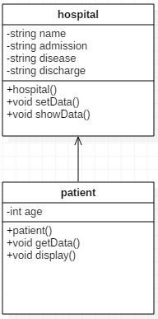 string name;

string admission;

string disease;

string discharge;

public:

hospital(){

name=" ";

admission=" ";

disease=" ";

discharge=" ";

}

void setData(){

fflush(stdin);

cout<<"Enter patient's name : ";

cin>>name;

fflush(stdin);

cout<<"Enter admission date : ";

cin>>admission;

fflush(stdin);

cout<<"Enter patient's disease : ";

cin>>disease;

fflush(stdin);

cout<<"Enter discharge date : ";

cin>>discharge;

fflush(stdin);

}

void showData(){

cout<<"\n\nName : "<<name<<endl<<"Admission date : "<<admission<<endl<<"Disease : "<<disease<<endl<<"Date of discharge : "<<discharge<<endl;

}

};

class patient : public hospital{

private:

int age;

public:

patient(): age(0)

{}

void getData(){

hospital::setData();

cout<<"Enter patient's age : ";

cin>>age;

}

void display(){

hospital::showData();

cout<<"Age : "<<age<<endl;

}

};

int main(){

int n;

cout<<"How many patient's data you want to store ? : ";

cin>>n;

patient p[n];

for(int i=0;i<n;i++){

p[i].getData();

}

for(int i=0;i<n;i++){

p[i].display();

}

return 0;

}

